TERRAFORM SPOTIFY PROJECT

STEPS:

REQUIREMENTS:

1. PHYSICAL MACHINE OR VM (EC2)

1.1 TERRAFORM INSTALLATION TO LAOCAL MACHINE Also add the Terraform EXTENSION in VS code(code editor)

1.2. DOCKER INSTALLATION to local Machine

2. SPOTIFY DEVELOPER ACCOUNT CREATION AND SPOTIFY WEB LOGIN ACCOUNT

STEP1:

SPOTIFY ACCOUNT

* CREATE THE APP VIA DASHBOARD:
* Using NAME, Description, Redirect URL

Example:

JobName: **terraform Spotify Demo Project playlist**

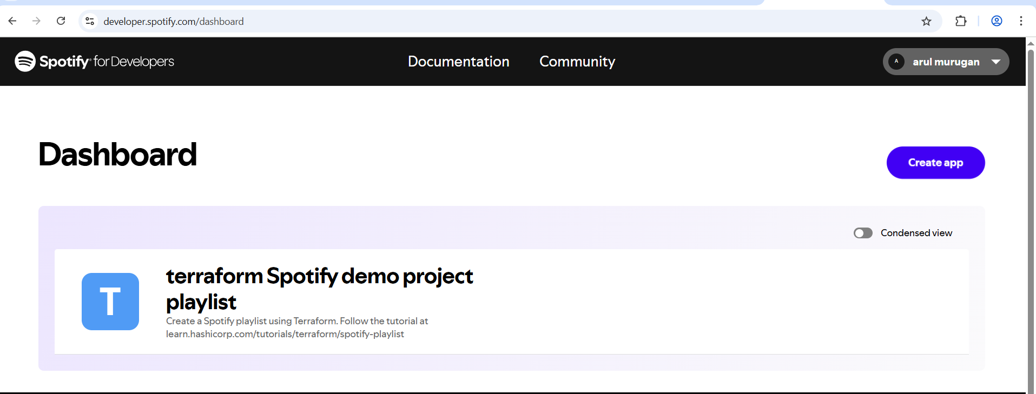

* Select Your Project go to setting click the Basic Information to Get
* CLIENT ID, SECRETE KEY and REDIRECT URL

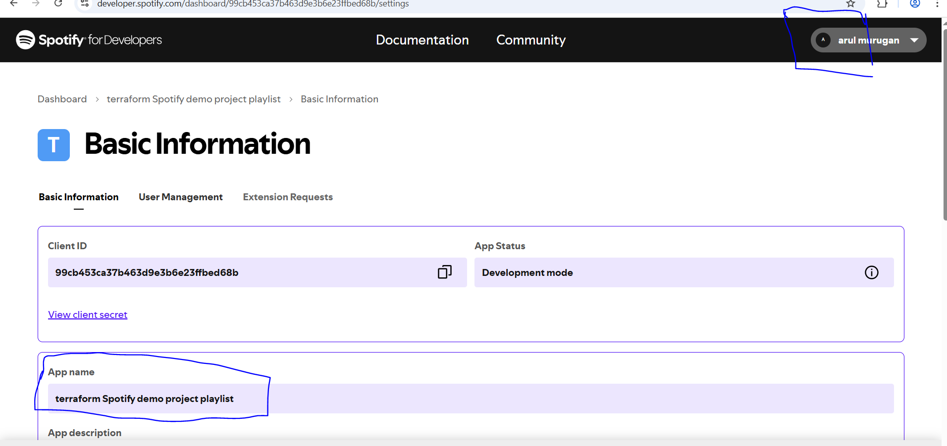

STEP2:

INSTALLATION:

DOCKER ,TERRAFORM

Docker install:

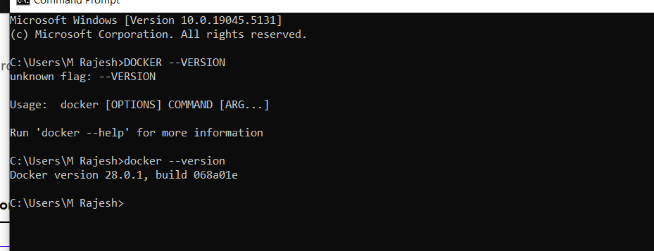

Terraform installation:

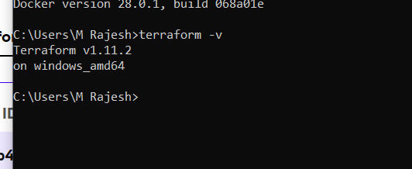

Extension Add:

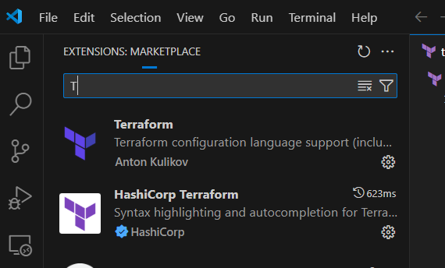

VS code:

Open VS code

Create a folder to your local working directory specified terraform project

Folder name: E:\SPOTIFY\devopslogin360\TERRAFORM\SPOTIFYTEST (my directory)

Go to vs code open folder (current directory)terraform

STEPS 3:

API KEY GENERATION:

Before key generation you have to first start the Dockers Engine (*)

* USING DOCKER RUN command TO CREATE THE API KEY and URL

Where find the Docker run command ie. terraform Spotify project documentation.

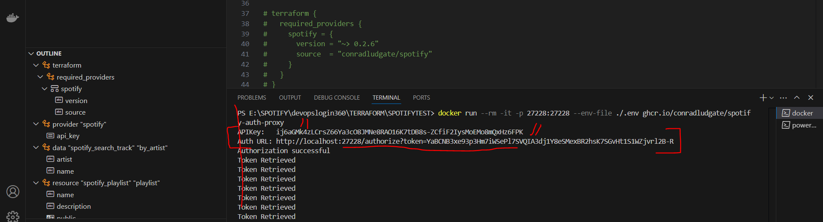

* Once create the API Key take copy and save the note pad

URL AUTHORIZATION SPOTIFY:

* Have you take the AuthURL put into Browser then Agree URL.
* Authorization Successful message shows.

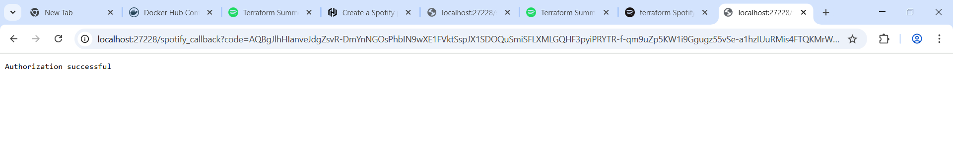

Once complete the Verification Add correct API key to **Main.tf file** and **terraform.tfvar** file in code section

TERRAFORM CODE IN VS

**Files Needed for Project:**

* Main.tf
* Variable.tf
* .env
* Terraform.tfvars
* Output.tf

Code:

Write a terra form code for Spotify project:

1. main.tf file creation

terraform {

  required_providers {

    spotify = {

      version = "~> 0.2.6"

      source  = "conradludgate/spotify"

    }

  }

}

provider "spotify" {

  api_key = var.spotify_api_key

}

# Search for tracks by Dolly Parton

data "spotify_search_track" "by_artist" {

    artist = "Anirudh Ravichander"

    #album = "Amaran"

    name  = "Hukum"

  #artist = "Dolly Parton"

  #limit  = 5  # Optional: specify the number of results to return

}

resource "spotify_playlist" "playlist" {

  name        = "Terraform Summer Playlist 360"

  description = "This playlist was created by Terraform"

  public      = true

  tracks = [

    # Ensure that the track exists before referencing it

    length(data.spotify_search_track.by_artist.tracks) > 0 ? data.spotify_search_track.by_artist.tracks[0].id : null,

    length(data.spotify_search_track.by_artist.tracks) > 1 ? data.spotify_search_track.by_artist.tracks[1].id : null,

    length(data.spotify_search_track.by_artist.tracks) > 2 ? data.spotify_search_track.by_artist.tracks[2].id : null

  ]

}

1. variable.tf:

variable "spotify_api_key" {

  type = string

  description = "Set this as the APIKey that the authorization proxy server outputs"

}

1. terraform.tfvars

spotify_api_key="ij6aGMk4zLCrsZ66Ya3cO8JMNe8RAO16K7tDB8s-ZCfiF2IysMoEMo8mQxHz6FPK"

1. output.tf

output "playlist_url" {

  value       = "https://open.spotify.com/playlist/${spotify_playlist.playlist.id}"

  description = "Visit this URL in your browser to listen to the playlist"

}

5 . ENV FILE:

Take the client id and secrete key From Spotify setting

Create file .env Paste this content and save it

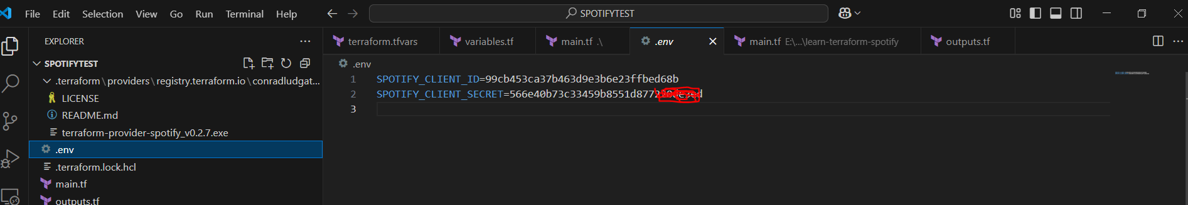

TERRAFORM RUN:

* terraform init
* terraform plan
* terraform apply

TERRAFORM INIT

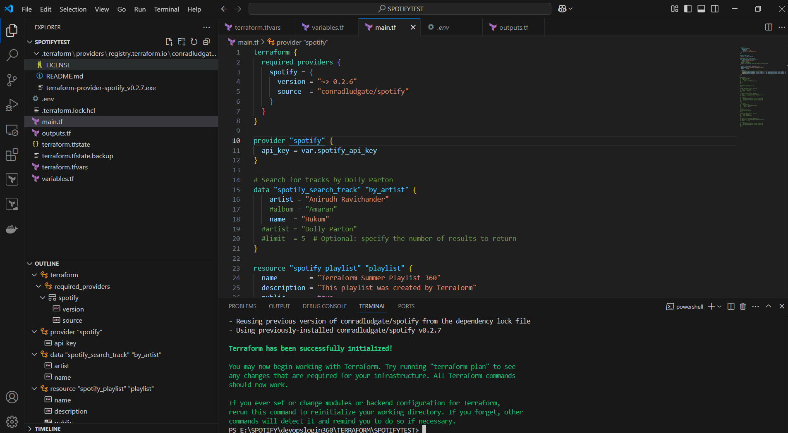

TERRAFORM PLAN

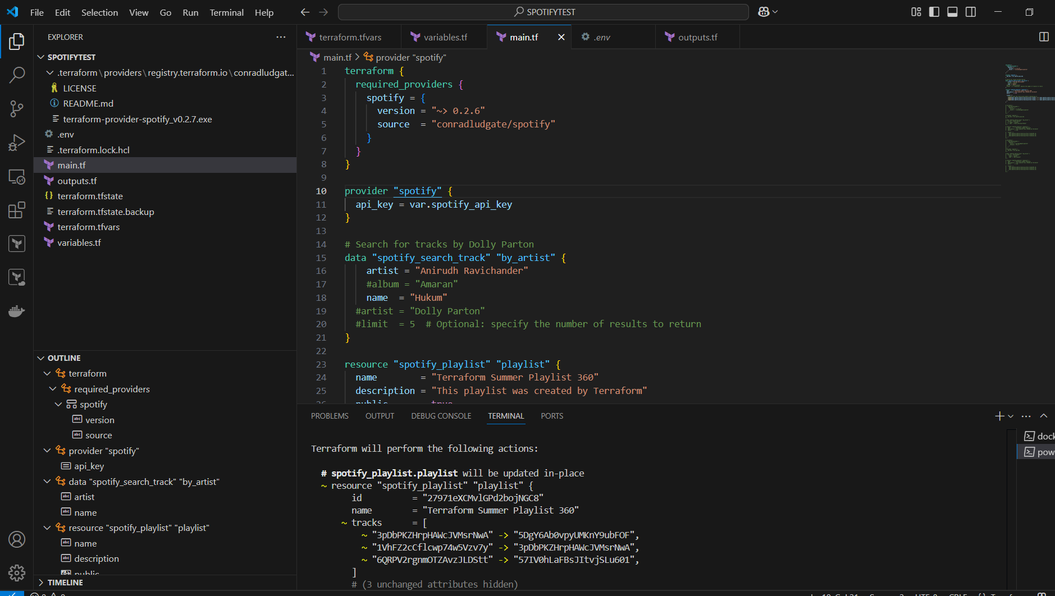

TERRAFORM APPLY

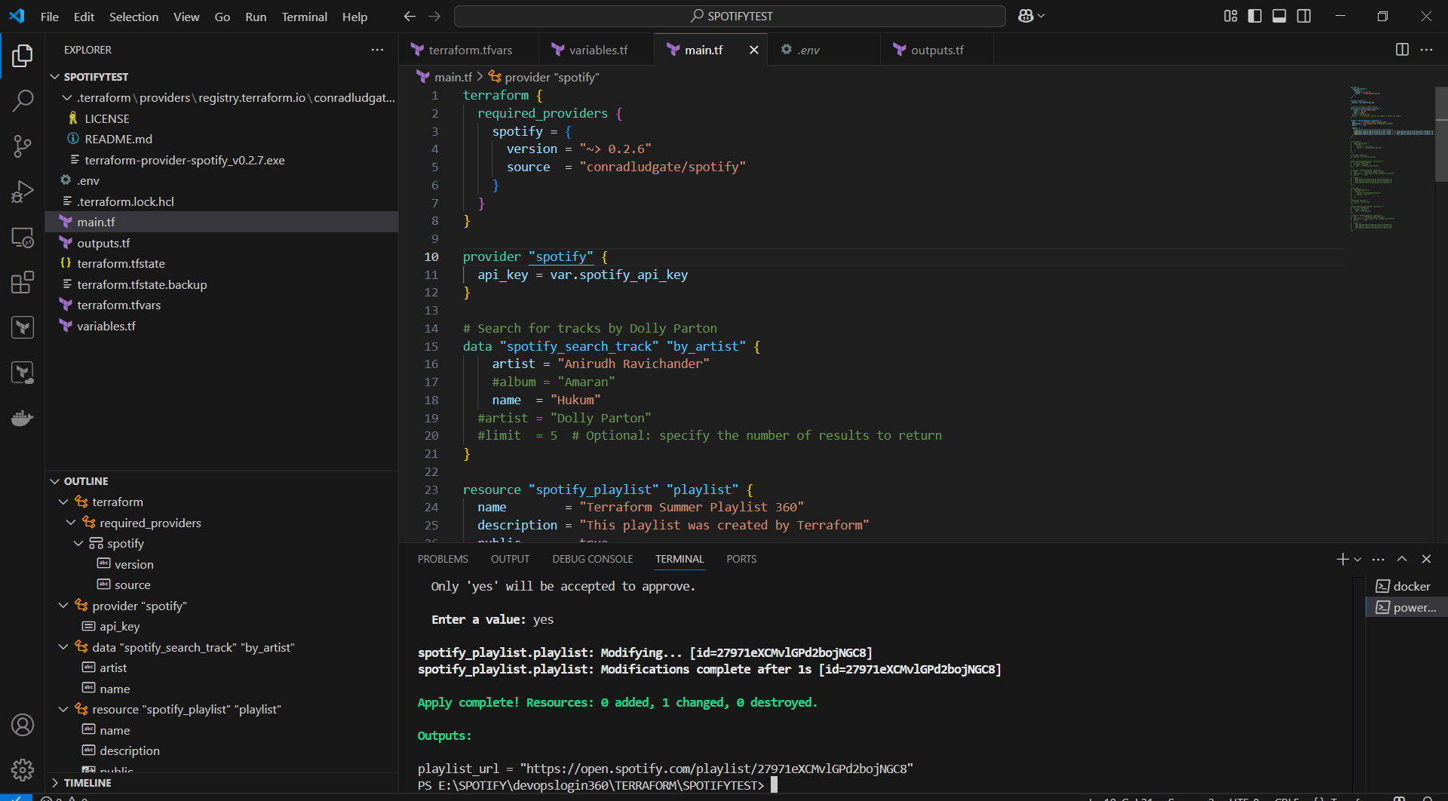

Project verification:

* Refresh the Spotify web login page and verified the Artist name and Song Name

Example:

Artist: Aniruth

Song: Hukum

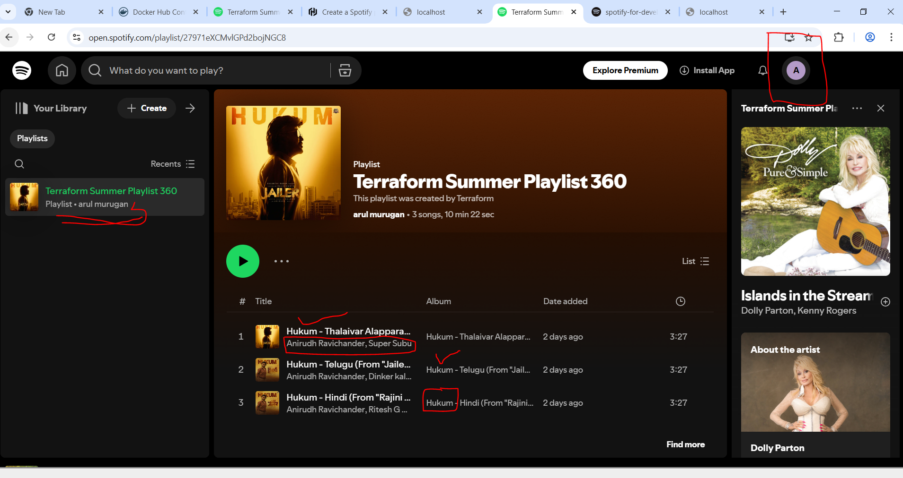

Successfully Add the terraform Playslist to Spotify Account